**Fort Reports Development Notes**

The app needs to read and write to the SQLite database stored internally in the app. There are four main pages to the app. Below is a description of each and the database tables it interacts with.

See the help page here for more details on functionality <http://fortreports.com/help.html> and the videos here <https://www.youtube.com/channel/UCH718pWdhYHkA_J8CqWTy5A>

**Setup - Reports**

This page shows a list of all of the report addresses on the left and a form to add/edit report addresses on the right. The report addresses are stored in the database table **FRADDRESS** and **FRADDRESSDEMO**

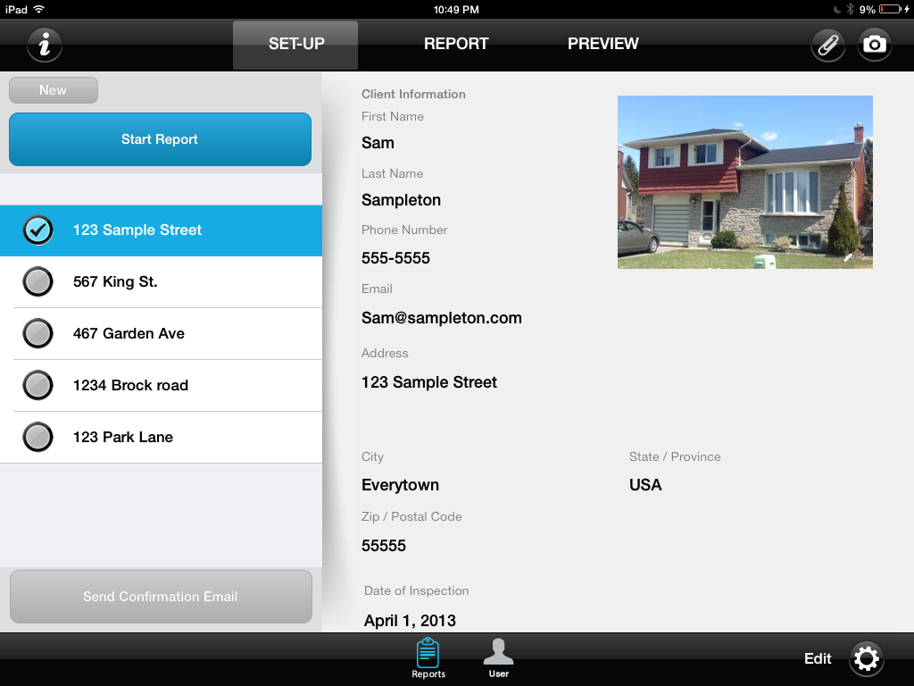

**Setup - User**

This page is a single form that allows the user to edit their profile information and purchase credits. User data is stored in the database table **FRADDRESS** and **FRADDRESSDEMO** in the row FA_REPORTNAME = ‘USERPROFILE’

**Report**

This page is the most complicated. This is where the user creates their report. On the left is a list of categories. On the bottom is buttons for each section of the house. Each section has it’s own list of categories (Table: **FR_CATEGORY_NAMES**).. On the right is the list of selections (Table: **FR_ITEM_SELECTIONS**) for the selected category, and the details button leads to a second list of selections for the selected category (Table: **FR_ITEM_SELECTIONS**)

All data the user enters is stored in the table **FORTREPORT**.

The table FR_ADDITIONAL_CATEGORIES stored the categories when users add their own .

On the bottom right is the “control panel” this shows 4 items: compass to store location (FR_TYPE=’compass’, bars to store floor ( FR_TYPE=’floor’ **)**, life expectancy (FR_TYPE=’life’ ) and cost (FR_TYPE=’cost’). The user clicks the bar or compass item to select it, and clicks it again to de-select it.

The address of the current report should show in the top right corner

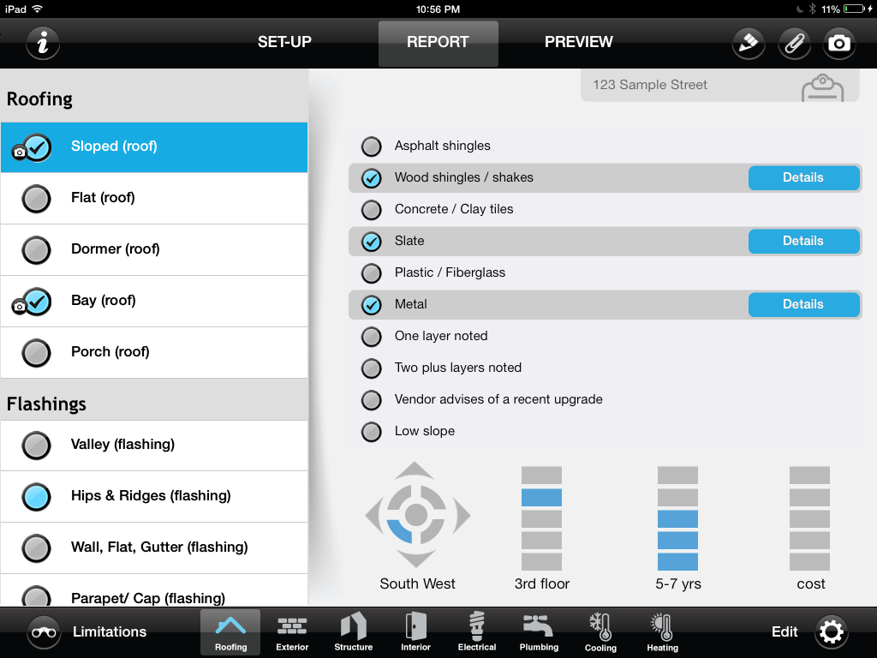

**Reports - Camera**

Clicking the camera icon on the top right of the reports page opens the camera window. Users can take up to 4 images for each category. Users can also draw on the image by clicking the draw button and using their finger to draw circles and arrows on the image

Image file names are made up of the report address, the users account email and the section and category name. The image name is stored in the table **FORTREPORT** with FR_TYPE=’PHOTO’along with the corresponding data attaching it to the correct section and category

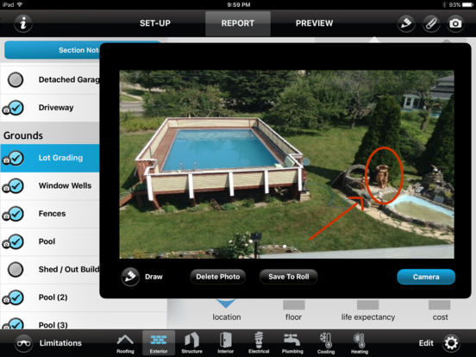

**Preview**

On this page the user can preview the report they have created . They can see the whole report at once , or click the section buttons at the bottom to preview just that section. The preview will show the images (up to 4) and the report data for each category.

From this page users can also upload data to the server ( we will build this part) and enter email addresses the report should be sent to. Email addresses from the setup page should be pre-filled on this page.

The address of the current report should show in the top right corner

